14.64: The buoyant force on the mass A, divided by(see Example 14.6), so the mass block is 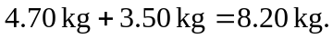a) The mass of the liquid displaced by the block is 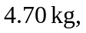so the density of the liquid is 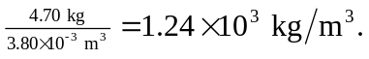b) Scale D will read the mass of the block, 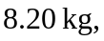as found above. Scale E will read the sum of the masses of the beaker and liquid, 